A Mini-Project Report

on

***Text to speech converter for visually*** ***impaired people***

SUBMITTED BY

**Student Name.**  **Exam seat No**.

1.Suyash Pulate T150083110

2.Sagar Warungase T150083147

3.Suyash Awathe T150083019

Name of project guide

Mrs.Manisha Rajput



**DEPARTMENT OF ELECTRONICS AND TELECOMMUNICATION**

D.Y.PATIL COLLEGE OF ENGINEERING

AKURDI, PUNE – 411044

SAVITRIBAI PHULE PUNE UNIVERSITY

2020-2021

**D. Y. PATIL COLLEGE OF ENGINEERING**

**AKURDI, PUNE – 411044**

**Department of Electronics and Telecommunication**

***CERTIFICATE***

This is to certify that **(Student name) – (Exam. Seat no)** of T.E. Electronics & Telecommunication Department have successfully completed Mini-Project titled ‘**Text to Speech Converter for Visually Impaired People**’ under my supervision and submitted the seminar report towards partial fulfillment of requirement for third year Engineering course under the Savitribai Phule Pune University during the academic year 2020-2021.

**Student Name.**  **Exam seat No**.

1.Suyash Pulate T150083110

2.Sagar Warungase T150083147

3.Suyash Awathe T150083019

Name of project guide Dr. Mrs. P. Malathi

**Mrs.Manisha Rajput H.O.D. E&TC**

**D. Y. PATIL COLLEGE OF ENGINEERING**

**AKURDI, PUNE – 411044**

**Department of Electronics and Telecommunication**

***CERTIFICATE***

This is to certify that following students of T.E. Electronics & Telecommunication department have successfully completed Mini-Project titled ‘**Text to Speech Converter for Visually Impaired People**’ under my supervision and submitted the seminar report towards partial fulfillment of requirement for third year Engineering course under the Savitribai Phule Pune University during the academic year 2020-2021.

**Student name Exam. Seat No.**

1.Suyash Pulate T150083110

2.Sagar Warungase T150083147

3.Suyash Awathe T150083019

Name of project guide Dr. Mrs. P. Malathi

**Mrs.Manisha Rajput H.O.D. E&TC**

External Examiner

ACKNOWLEDGEMENT

We express our sincere gratitude towards the faculty members who makes this seminar a successful.

We would like to express our thanks to our guide Mrs. Manisha Rajput for her whole hearted cooperation and valuable suggestions, technical guidance throughout the seminar work.

We would like to express our special thanks to our H.O.D. Dr. Mrs. P. Malathi for her kind official support and encouragement.

Finally, we would like to thank all our faculty & staff members of E&TC Department who helped us directly or indirectly to complete this work successfully.

Name of the students

1.Suyash Pulate

2.Sagar Warungase

3.Suyash Awathe

**Abstract** :

A Text-to-speech synthesizer is an application that converts text into spoken word, by analyzing and processing the text using Natural Language Processing (NLP) and then using Digital Signal Processing (DSP) technology to convert this processed text into synthesized speech representation of the text. Here, we developed a useful text-to-speech synthesizer by using arduino uno that converts inputted text into synthesized speech and reads out to the user . The development of a text to speech synthesizer will be of great help to people with visual impairment and make making through large volume of text easier.

**Contents**

|  |  |  |
| --- | --- | --- |
| **Sr. No.** | **Chapters** | **Page No.** |
|  | Introduction   * 1. Motivation   2. Objective | 8 |
|  | Literature Survey   * 1. Fig, references, links, etc   2. Feasibility study | 9 |
|  | Proposed Methodology  3.1 Block diagram | 10 |
|  | Project Implementation  4.1Circuit Diagram & working   * 1. Simulation   2. Selection of components | 11 |
|  | PCB design & Testing   * 1. PCB design   2. Mounting & soldering   3. Testing of PCB | 15 |
|  | Results & Future work   * 1. Results (with tables & Figures)   2. Future scope   3. Conclusion | 16 |
|  | References |  |

**List of Figures**

|  |  |  |
| --- | --- | --- |
| **Sr. No.** | **Title** | **Page No.** |
| 1 | Block diagram(Text to speech converter) | 10 |
| 2 | Block diagram(Text to speech synthesizer) | 10 |
| 3 | Circuit Diagram | 11 |
| 4 | Simulation | 13 |

**CHAPTER 1**

**1.Introduction**

**1.1 Motivation**

Text to speech converter can be used for many application, such as Audio books,Google assistant,etc. We use of text to speech converter very frequently and it has become very common to us . People with visual impairment face difficulties in their daily life to read or access printed text documents,even people with low vision also face similar difficulties while dealing with text documents.Here, text to speech converter will be of great help to such people,as it can read any text aloud whatever that has been written on screen .

**1.2 Objective**

* Aim of our proposed project is to overcome the reading problems of Visually Impaired(VI) people.This project will assist the blind people to read text printed on pamphlets, newspapers and books.

**CHAPTER 2**

**2.Literature Survey**

**2.1** **References / links**

* Research Paper

https://core.ac.uk/download/pdf/83592918.pdf

**CHAPTER 3**

**3.Proposed Methodology**

**3.1 Block Diagram of Text to Speech Converter**

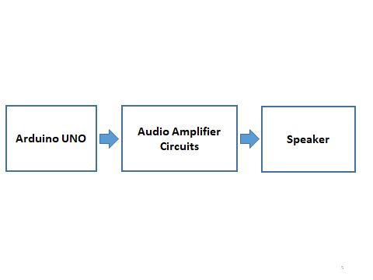

**For working inside Arduino UNO**

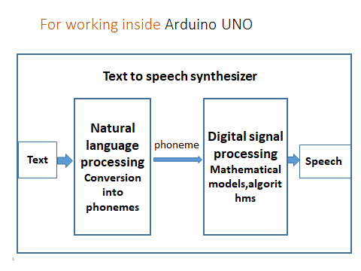

**CHAPTER 4**

**4.Project Implementation**

**4.1 Circuit Diagram:**

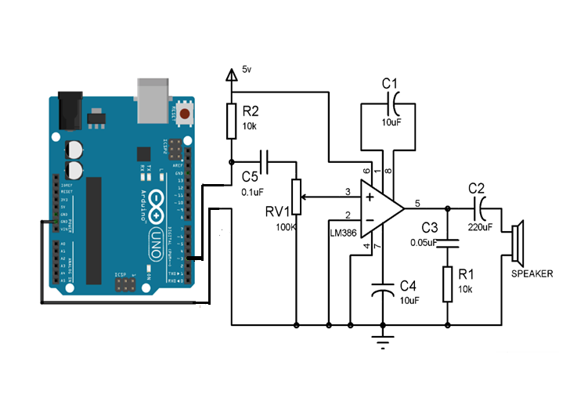

**Working:**

**Arduino part:**

A Text-to-speech synthesizer is a module that converts text into spoken word, by analyzing and preprocessing the text using Natural Language Processing (NLP) and then using Digital Signal Processing (DSP) technology to convert this processed text into synthesized speech representation of the text.

**1.Natural Language Processing Phase** consist of Preprocessing stage and Conversion stage

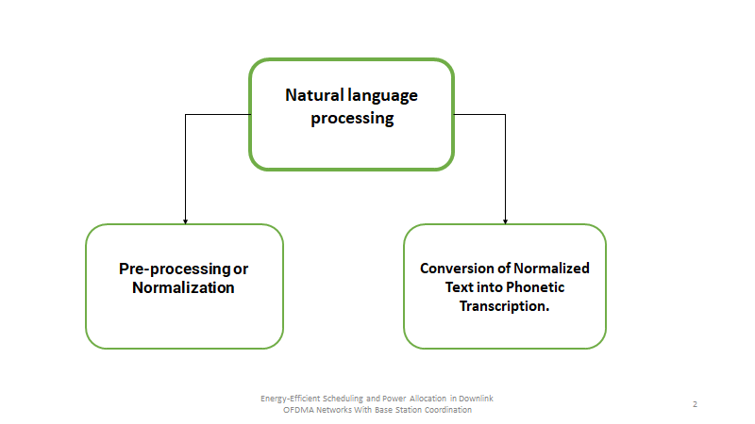

* Preprocessing stage involves the conversion of the symbols, numbers and abbreviations into words that can be read by the machines like ‘?’ will be converted into “question mark”.
* Conversion of Normalized text into Phonemes

The phonemes are the small parts of spoken words i.e. these are the sounds that make sentences. This step is really essential so that machine can speak the words as humans do

**2.Digital Signal Processing (DSP) phase**

* It can be achieved by different methods like by recording the human voice for different words/phrases or by generating basic sound frequencies as phonemes or by copying human speaking mechanisms.
* It transforms the symbolic information it receives from NLP into audible and intelligible speech

**Arduino and LM386 interfacing:**

* Arduino Uno is interfaced with a low voltage audio amplifier(LM386).
* LM386 is an 8 pin audio amplifier with input voltage range(4-15V).Here, we have used a 9v battery for power supply.
* PWM pin(3) of Arduino, which gives low frequency signal as output, is connected to the Non-inverting terminal(Pin 3) of LM386 through variable resistance(100k) and capacitor C5 (0.1uF).
* Inverting terminal (Pin 2) of LM386 and GND pin of Arduino is connected to ground.
* Capacitor C1(10uF) is connected between Pin 1 and Pin 8.The aim of this capacitor is to increase the gain of amplifier upto 46dB. If no capacitor is connected,it’s gain will be upto 26dB only.
* Pin 7 is connected to ground through C4(10uF).Here,C4 acts as filter capacitor to avoid unnecessary oscillations.
* The RC network of C3(0.05uF) and R1(10k) is connected in parallel to the output pin ,to control the volume of Speaker.
* Output Pin 5 of LM386 is connected to an 8Ω speaker, which gives the amplified output in the form of speech.

**4.2 Simulation**

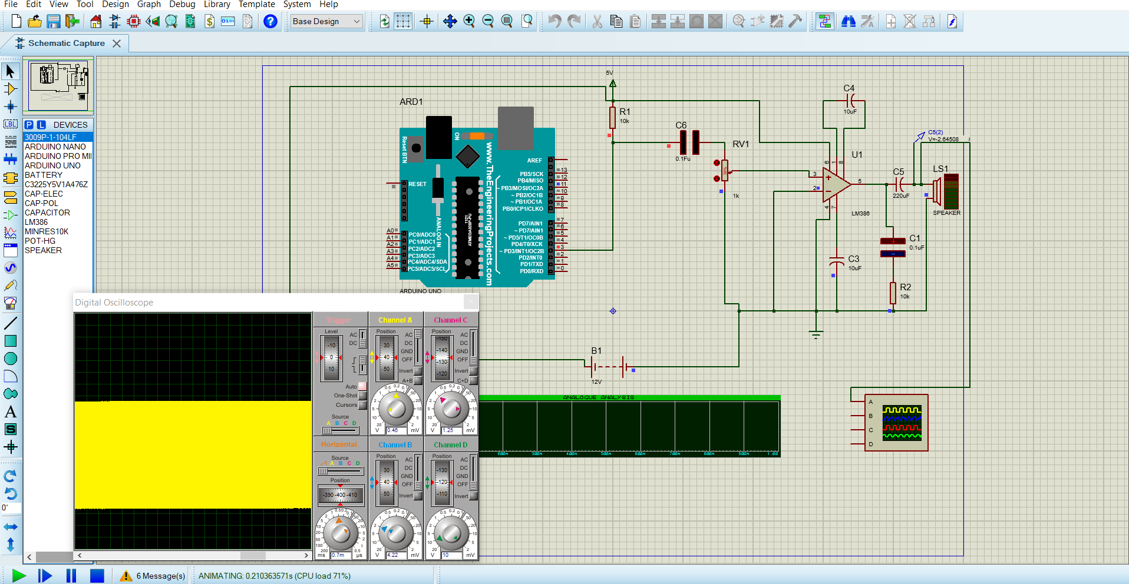

**4.3 Selection of Components:**

1. Arduino Uno

2. Audio Amplifier LM386

3. Resistors (10kΩ, 100kΩ)

4. Capacitors (0.05uF , 0.1uF ,10uF , 220uF )

5. Speaker (8Ω, 5V)

6. 9V Battery

7. Buck converter

**CHAPTER 5**

**5.PCB Design**

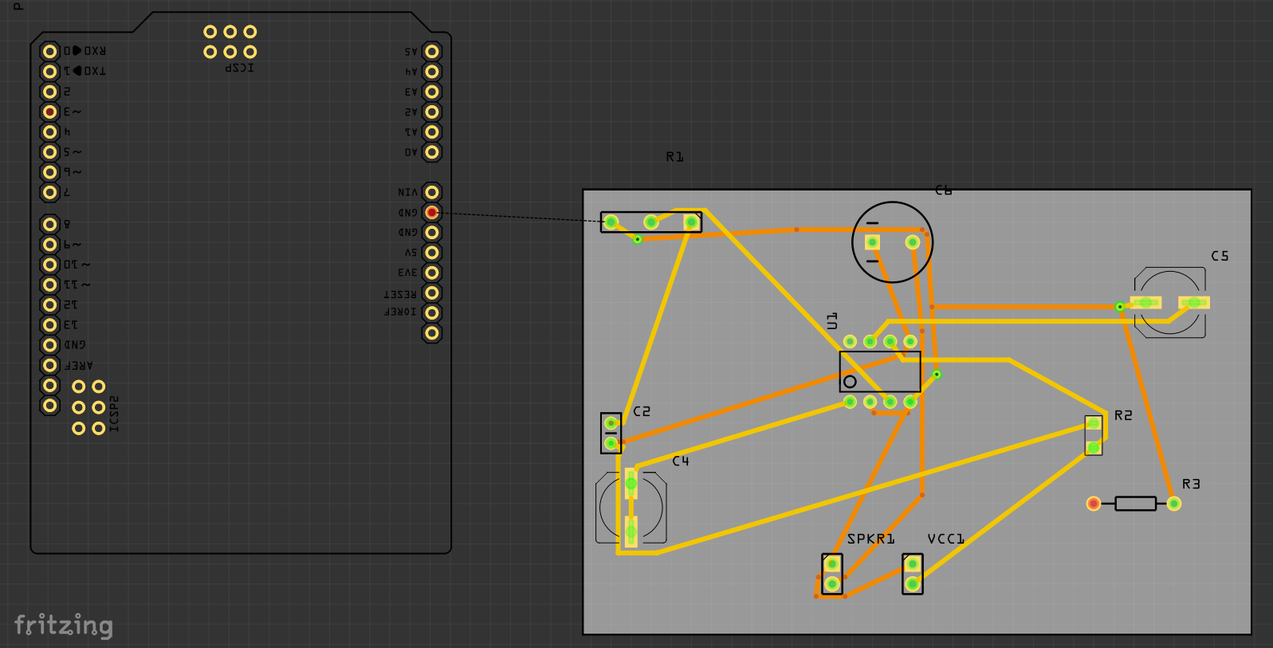

+

**CHAPTER 6**

**6.1 Result**

After performing a simulation of the TTS circuit , we are able to observe the changes at the speaker end as speech signals are generated after TTS conversion.

**6.2 Future scope**

* In a text to speech converter the text is already fed or given with the help of a keyboard , which is then converted into text.
* Similarly, with the help of speech to text converter it will be possible to convert speech into text.
* Eventually, we can include language translators to convert one language to any native language,which will help people to understand text easily in their native language .

**6.3 Conclusion**

Providing visually challenged people with better reading abilities has been a major challenge.This TTS system aims at providing a better option for such people.Text given to the text to speech converter can be converted into speech with the help of Arduino and built in libraries . This project ,once implemented with proper programming , libraries and different language support , will be of great help to visually impaired people. Further development includes providing a sense of direction to the person reading something.